Beam Mechanics Simulator

Aim:
The aim of this experiment is to analyze the behavior of a simply supported beam under different loading conditions using simulation. It focuses on studying the shear force and bending moment distribution, determining the maximum bending moment and stress, and evaluating the factor of safety for different materials. The experiment also helps in understanding how point loads, uniformly distributed loads, and their combination affect the structural performance and safety of the beam.

Theory:
this experiment is based on the principles of structural analysis of simply supported beams under external loads. When a beam is subjected to loads such as a point load or a uniformly distributed load (UDL), reaction forces develop at the supports to maintain equilibrium, satisfying the conditions ΣF = 0 and ΣM = 0. The variation of internal forces along the beam is represented using the Shear Force Diagram (SFD) and Bending Moment Diagram (BMD). The bending moment at any section causes internal stresses in the beam, which are calculated using the flexure formula (σ = My/I), where the stress depends on the bending moment, distance from the neutral axis, and the moment of inertia of the cross-section. For a circular beam, the moment of inertia is given by πD⁴/64. The maximum bending stress is compared with the material’s yield strength to determine the Factor of Safety, which indicates whether the beam is safe or will fail. This theory helps in understanding how different loading conditions influence beam strength, deformation, and structural safety.
An example of shear force and bending moment diagram calculations is given,

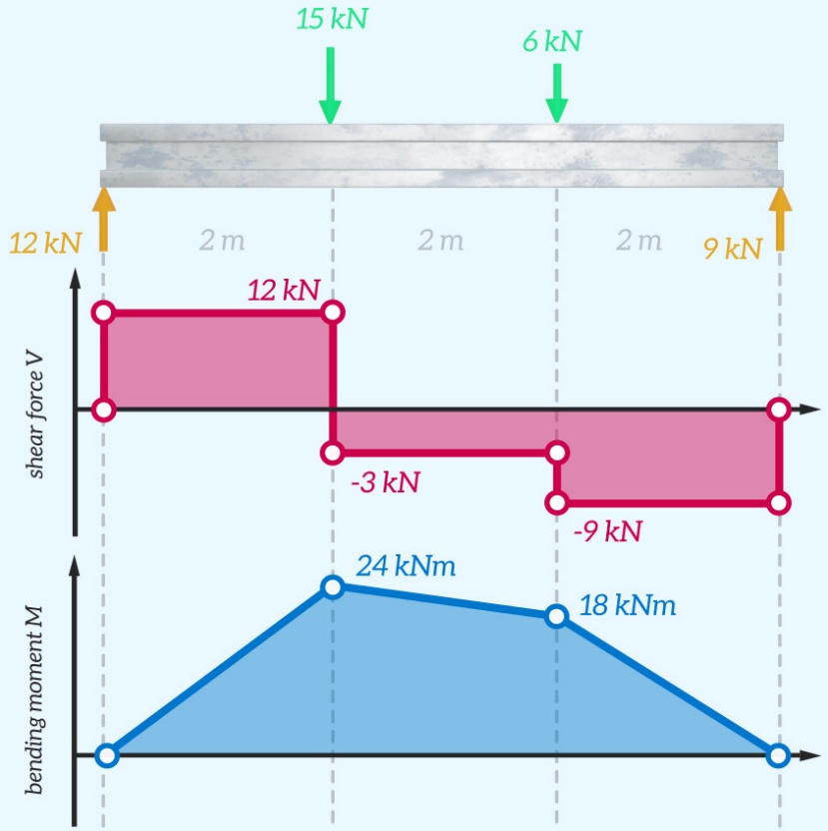

Formula:
• Shear Force (SF):
$$V(x)=R_{A}-wx-P⋅H(x-a)$$
• Bending Moment (BM):
$$M(x)=R_{A}x-\frac{wx^{2}}{2}-P⋅⟨x-a⟩$$
• Reactions:
$$R_{B}=\frac{Pa+wL^{2}/2}{L} \\ R_{A}=P+wL-R_{B}$$

Simulation:
This simulation is a beam analysis tool used to study the behavior of a simply supported beam under different loading conditions. The user can apply a point load, a uniformly distributed load (UDL), or both, and adjust parameters like beam length, load position, and diameter using sliders. Based on these inputs, the simulation calculates the support reactions using equilibrium conditions and generates the Shear Force Diagram (SFD) and Bending Moment Diagram (BMD) in real time. It also determines the maximum bending moment and its exact location, then computes the bending stress using standard beam theory. This stress is compared with the material’s yield strength to calculate the Factor of Safety and indicate whether the beam is safe or will fail. If failure occurs, the exact location is highlighted, making the simulation a useful tool for understanding structural behavior and safety.

Example:
A simply supported beam of length 6m, carries point load of 3kN and 6kN of 2m and 4m from the left end. Draw the SF and BM diagrams for the beam.
Solution:
Find the reaction at A and B as R_{a} and R_{b}
Step1: Take moment about A is equal to zero
R_{b} x 6 – (6 x 4) – (3 x 2) = 0>> R_{b} x 6 = (6 x 4) + (3 x 2)/6 >> R_{b} = 5kN
Step2: Sum of upward force = Sum of downward force
R_{a} + R_{b} = 6 + 3 >> R_{a} = 9 – R_{b} >> R_{a} = 9 - 5 = 4kN
Shear Force Calculation: (Sum of vertical forces)
SF at B = -R_{B} - 5 kN
SF at C = -5 +6 = + 1kN
SF at D = - 5 +6 + 3 = + 4 kN
SF at A = - 5 +6 + 3 = + 4 kN

Bending moment Calculation:
[Sum of (Vertical force x Distance of load acting from required section)]
BM at B = + (R_{b} x 0) = 0 kNm
BM at C = +(5 x 2) – (6 x 0) = + 10 kN
BM at D = +(5 x 4) –(6 x 2) –(3 x 0) = + 8 kN
BM at A = +(5 x 6) –(6 x 4) –(3 x 2) = 0 Kn
The SFD and BMD are given below
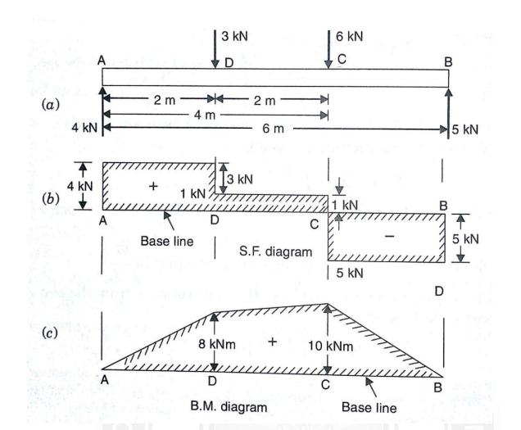

Result:
The simulation accurately generated SFD and BMD and correctly calculated reactions, bending moment, stress, and factor of safety. The results matched theoretical values, confirming the validity of the experiment.

